**EXPLANATION FOR TASK 2**

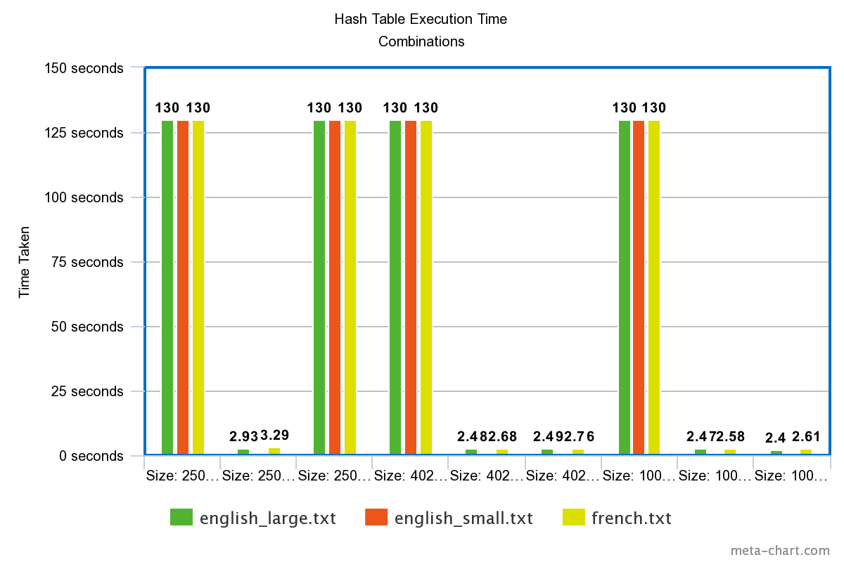

The table size should generally be balanced and kept in a sane ratio compared to the number of input keys. Having said that, when the hash function is as basic as the one used in this Interview Practical, it helps to have a table size that reduces collisions as much as possible. Having a table size that is a prime number helps reduce collisions as prime numbers do not have a lot of common factors.

Meanwhile, hash base should be a value that produces a hash that is fairly larger that the table size to reduce clusters and keep the hashes well scattered.

For the above graph,

1. **Base Value – 1:** shouldn't be small - it means the contribution of key[i] isn't likely to wrap h around the table many times before the % operation is applied again, losing all the benefits from that scattering the mapping around.
2. **Base value – 250726 and Table size – 250727:** This combination performs worse than the other combination since the base value should to larger than the table size as suggested on top.